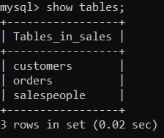

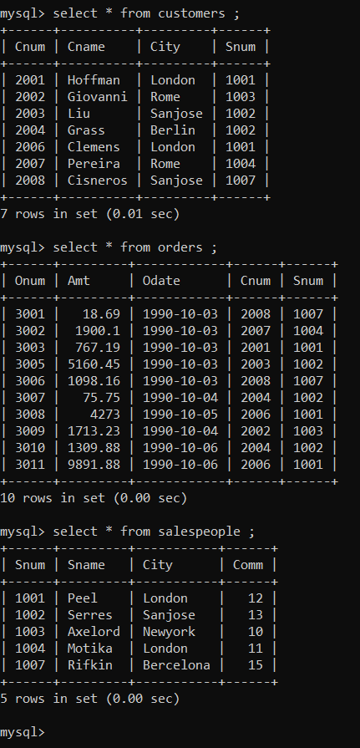

Q1. Count the number of Salesperson whose name begin with **‘a’**/**’A’**.

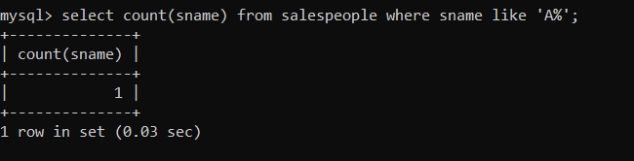

Q2.  Display all the Salesperson whose all orders worth is more than Rs. 2000.

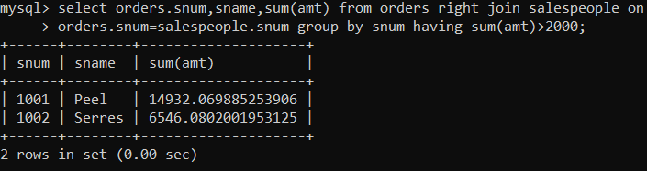

Q3. Count the number of Salesperson belonging to **New York**.

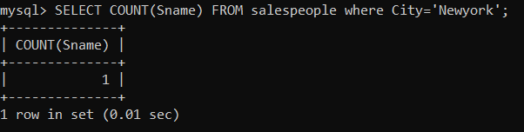

Q4. Display the number of Salespeople belonging to **London**and belonging to **Paris**.

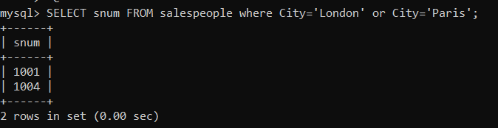

Q5. Display the number of orders taken by each Salesperson and their date of orders.

